s.no | 3 Dimensional shapes | Formula
1 | If a is the length of one side of a cube, what is the volume of the cube.  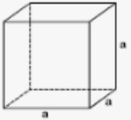
2 | If a is the length of one side of a cube, what is the curved surface area / lateral surface area of the cube.  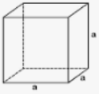
3 | If a is the length of one side of a cube, what is the total surface area of the cube.  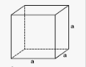
4 | If l is the length, w is the width and h is the height, what is the volume of the cuboids.  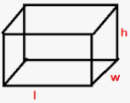
5 | If l is the length, w is the width and h is the height, what is the curved surface area / lateral surface area of the cuboids.  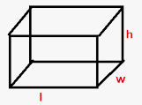
s.no | 3 Dimensional shapes | Formula
6 | If l is the length, w is the width and h is the height, what is the total surface area of the cuboids.  
7 | If r is the radius and h is the height what is the volume of the cyclinder.  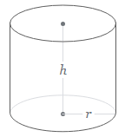
8 | If r is the radius and h is the height what is the curved surface area / lateral surface area of the cyclinder.  
9 | If r is the radius and h is the height what is the total surface area of the cyclinder.  
10 | If r is the radius and h is the height what is the volume of the cone.  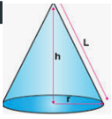
s.no | 3 Dimensional shapes | Formula
11 | If r is the radius and h is the height what is the curved surface area / lateral surface area of the cone.  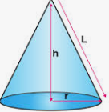
12 | If r is the radius and h is the height what is the total surface area of the cone.  
13 | If r is the radius what is the volume of the Sphere.  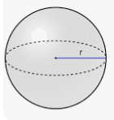
14 | If r is the radius what is the curved surface area / lateral surface area of the Sphere.  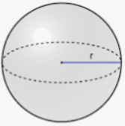
15 | If r is the radius what is the total surface area of the Sphere.  
16 | If r is the radius what is the volume of the hemisphere.  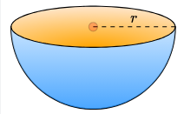
s.no | 3 Dimensional shapes | Formula
17 | If r is the radius what is the curved surface area / lateral surface area of the hemisphere.  
18 | If r is the radius what is the total surface area of the hemisphere.  

